Team 01 – Hampod2

User Manual
  - Written by: Andrew Mills, Salik Ahmad, Michael Trinh, Ethan Townsend

Table of Contents
1 Introduction 3
2 Hardware Information 3
2.1 Compute Board 3
2.2 NanoPi Neo 4
2.3 Keypad 4
3 Software Information 6
3.1 Introduction 6
3.2 Overview of Hamlib 6
3.3 Software Architecture 7
3.3.1 Hamlib Set Functions 7
3.3.2 Hamlib Get Functions 9
3.3.3 Software Modes Files 11
3.3.4 Radio Files 11
3.3.5 Startup Files 12
3.4 Extending Functionality 12
3.5 Usage and Operational Modes 12
3.6 Troubleshooting 13
3.7 External Resources 13
4 Setting Up the Hampod 14
5 Starting the Hampod 14
5.1 Introduction 14
5.2 Non-Save Startup 14
5.3 Save Startup 16
6 Using the Hampod 16
6.1 Modes 16
6.1.1 Configuration Mode 17
6.1.2 Frequency Mode 19
6.1.3 Normal Mode 19
6.1.4 Navigation between modes & creating new modes 20
7 Common Issues & Considerations 22
8 Appendix 22

1 Introduction
The HAMPOD project was initiated to increase the accessibility of amateur radio operations to blind and visually impaired users. The device was originally connected to radios and provided audio feedback for control parameters, such as frequency and modulation. However, the original device’s software had become outdated due to its reliance on assembly language for the PIC processor. The original device’s hardware has also become obsolete, making it harder to maintain and update. Some of the basic features include connecting and communicating with multiple rigs, being able to switch between several modes, and outputting text-to-speech for different actions. The Hampod will be equipped with USB ports for modern rigs and serial ports for the older models. The goal is to be able to handle more than two rigs at once when compared to the original model.

2 Hardware Information

2.1 Compute Board
The hardware of the Hampod is a NanoPi that is mounted on top of a PCB with IO breakouts. The breakout board contains 2 USB-A ports, a DB9 port for RS232 communication, an internal speaker amplifier, audio jack for external speakers, connectors to an internal matrix keypad, and a 5-volt DC power regulator. A 1A fuse is in the power supply circuit if a short occurs to prevent damage to the board. There are two methods of output available for use on the compute board depending on which radio is in use, USB and serial communication via the RS232 connector. There are two indicator LEDs on the design, one indicating that the board is receiving power and another indicating when audio is being played. Both indicator LEDs are used for testing and are not necessary for functionality. An image of the compute board without the nanoPi installed can be seen below in Figure 1.
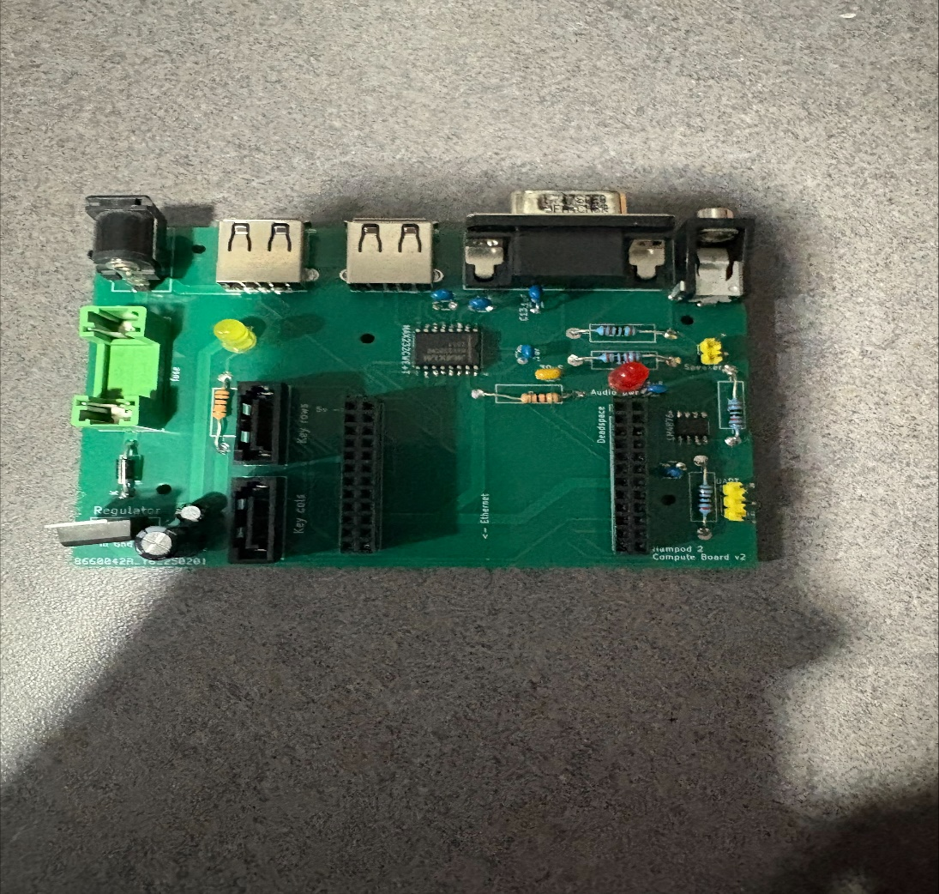
Figure 1: Image of Compute Board

2.2 NanoPi Neo
The NanoPi NEO is a single board computer (SBC) that runs our code. It has a quad-core CPU and 512 MB of memory. The code and files are stored on an SD card which allows users to have much more disk space than a regular microcontroller. This SBC also comes with USB which allows users to connect to newer radios which contain a USB port. The NanoPi is low cost and has a small footprint which allows it to be easily accessible to all users.
For more information about the NanoPi Neo the wiki is can be accessed here

2.3 Keypad
The keypad is the main form of interaction between the user and the system. The keypad consists of a matrix with 5 rows and 4 columns, as well as an external matrix containing an additional two keys. The keypad is designed to be a simple input that is easy for any user to operate. A picture of the keypad can be seen below in Figure 2. The keypad is connected to the compute board via SATA cables designed for a secure connection between the two. The external matrix with two additional keys is programmed to be shift and reset keys, these are highlighted below in the yellow box. The main 4x4 matrix highlighted below in the red box, provide the main functionality of the system including switching between modes, controlling settings on the radio etc. The top column of the keypad highlighted in blue are designed to be programmable tailored to each user's preferences.

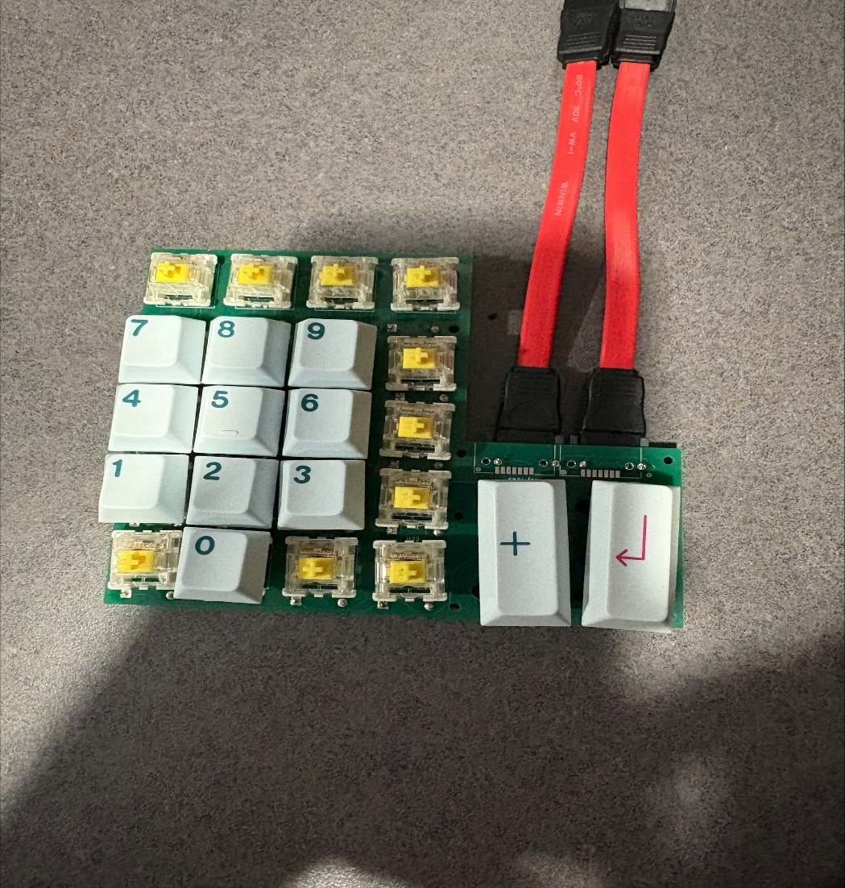
Figure 2: Image of keypad

3 Software Information

3.1 Introduction
Hampod is designed to provide a consistent and extendable software platform for controlling a wide range of amateur radio transceivers. By building on top of Hamlib, Hampod offers:
- Cross-platform compatibility: Works on Windows, Linux, and macOS.
- Wide device support: Interfaces with popular radio brands like Yaesu, Icom, Kenwood, and Elecraft.
- Rig control functionality: Configures frequency, mode, power, filters, and more.
- Remote control capabilities: Operate radios over network connections.
- Software development support: Easily integrates with various programming languages via Hamlibs’ bindings.
This manual details the software components, file structures, and functions used within Hampod to control radio hardware, and explains how to extend or modify its functionality.

3.2 Overview of Hamlib
Hamlib (short for "Ham Radio Control Libraries") is an open-source project that standardizes the interface for controlling amateur radio transceivers. Its key features include:
- Cross-Platform Compatibility: Ensures operation on various operating systems.
- Wide Device Support: Supports numerous radio models across different manufacturers.
- Rig Control Functionality: Provides functions for frequency, mode, power, and other rig parameters.
- Remote Operation: Enables controlling radios remotely over network connections.
- Developer Support: Offers programming language bindings for easy integration.
Hampod utilizes Hamlib to interact with radios, wrapping Hamlib functions in adapter files that simplify modification and future integration with other radio interface libraries.

3.3 Software Architecture
Hampod’s software architecture is organized into several key file groups, each serving a distinct purpose in interfacing with Hamlib and managing radio control operations.

3.3.1 Hamlib Set Functions
Purpose:
The HamlibSetFunctions files (with corresponding .c and .h files) act as an adapter layer for Hamlib. They contain wrapper functions that set various values on the rig (e.g., frequency, mode, VFO, PTT, and more).
Structure & Operation:
- Wrapper Functions:
Each function in this file:
  - Parses the provided void pointer array to extract the necessary parameters.
  - Calls the corresponding Hamlib "set" function.
  - Converts the output to a formatted string as specified by the command.
  - Returns the string output.
- Customization:
This design allows custom modification of string output and facilitates the replacement of Hamlib with another radio interface library without major changes to the system.
- Adding New Functionality:
To add a new Hamlib set function, copy and paste the template below, adjust the casting and output formatting, and insert the appropriate Hamlib call:
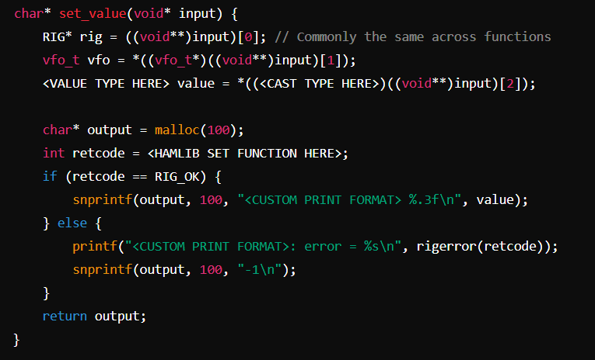
Figure 3: Example code snippet for Hamlib Set function
Currently Implemented Set Functions:
- set_frequency
- set_mode
- set_vfo
- set_ptt
- set_rit_offset
- set_xit_offset
- set_tuning_step
- set_CTCSS_sub_audible_tone
- set_current_encoding_digitally_coded_squelch_code
- set_current_CTCSS_sub_audible_squelch_tone
- set_current_continuous_tone_controlled_squelch_code
- set_level (for RIG_LEVEL features)
- set_func (for RIG_FUNC features)

3.3.2 Hamlib Get Functions
Purpose:
Similar to the set family of functions, the HamlibGetFunctions files (with .c and .h extensions) provide an adapter layer for hamlib’s “get” operations. These functions retrieve values from the rig (e.g., current frequency, mode, and other parameters).
Structure & Operation:
- Wrapper Functions:
Each "get" function:
  - Parses the provided void pointer array to extract parameters.
  - Calls the corresponding Hamlib "get" function.
  - Formats the output into a string.
  - Returns the formatted string.
- Customization:
This approach allows the user to modify the output format as needed.
- Adding New Functionality:
Use the template below to add a new get function:
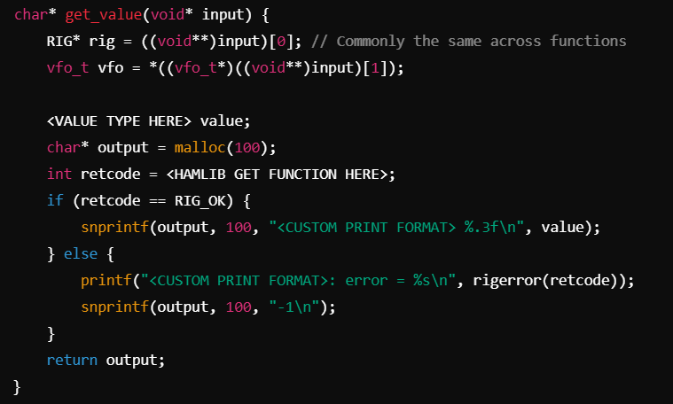
Figure 4: Example code snippet for Hamlib Get function
Currently Implemented Get Functions:
- get_frequency
- get_mode
- get_vfo
- get_ptt
- get_rit_offset
- get_xit_offset
- get_tuning_step
- get_CTCSS_sub_audible_tone
- get_current_encoding_digitally_coded_squelch_code
- get_current_CTCSS_sub_audible_squelch_tone
- get_current_continuous_tone_controlled_squelch_code
- get_level (for RIG_LEVEL features)
- get_func (for RIG_FUNC features)

3.3.3 Software Modes Files
Purpose:
The Modes files (.c/.h) handle the operational modes of Hampod. They integrate functions from both the HamlibSetFunctions and HamlibGetFunctions files as well as other external functions acting as adapters.
Operational Modes:
- Normal Mode:
Uses adapter functions to both set and get rig parameters.
- Frequency Mode:
Directly calls Hamlib functions (a transition to adapter functions is planned).
- Monitoring Mode:
Also uses a combination of Hamlib set and get functions to monitor radio status.

3.3.4 Radio Files
Purpose:
The Radio files encapsulate essential information about the connected radio. They manage the radio’s identity and connection parameters, such as the rig_model_t and port, which are critical for Hamlib functionality.
Key Operations:
- Initialization:
  - rig_init is called to initialize the rig.
  - rig_set_conf sets the configuration (e.g., port selection).
  - rig_open establishes the connection between the user’s radio and Hampod.
- Cleanup:
When the connection is terminated, the freeRadio function performs:
  - rig_close to close the connection.
  - rig_cleanup to free allocated memory associated with the rig.

3.3.5 Startup Files
Purpose:
During startup, the system uses Hamlib to retrieve a list of supported rigs. The process involves:
- Calling rig_list_foreach(callback, &rig) to iterate over every supported rig.
- Extracting information such as rig ID and model from each rig object.
- Appending the rig information to the corresponding manufacturer’s text file.
This mechanism ensures that Hampod can dynamically extend its support for new radio models, enhancing its longevity and adaptability.

3.4 Extending Functionality
Hampod’s design emphasizes extensibility. Whether you need to add new set or get functions, the process is straightforward:
- Copy a Template:
Use the provided templates in the HamlibSetFunctions or HamlibGetFunctions sections.
- Adjust Parameter Types and Casting:
Modify the value type and casting to match the new functionality.
- Insert the Appropriate Hamlib Call:
Replace the placeholder with the corresponding Hamlib function (e.g., a new frequency setting or retrieval function).
- Customize Output Formatting:
Adjust the output string formatting as needed to meet your application’s requirements.
This modular approach ensures that you can integrate additional Hamlib-supported features with minimal changes to the overall system.

3.5 Usage and Operational Modes
Hampod supports several operation modes, each tailored to specific use cases:
- Normal Mode:
The standard mode for general radio operations, combining both setting and getting rig parameters.
- Frequency Mode:
Focused on frequency-specific operations, though it currently calls Hamlib functions directly. Future revisions aim to fully integrate adapter functions.
- Monitoring Mode:
Designed for continuous monitoring of radio status, employing both set and get functions from the Hamlib adapter files.

3.6 Troubleshooting
- Function Failures:
If a set or get function returns an error (often indicated by a return code other than RIG_OK), the function will print an error message using rigerror(retcode) and return -1. Check your rig’s compatibility and verify the parameters being passed.
- Unsupported Functions:
Some functions may not work with certain radio models either because Hamlib does not support them or they have not been fully tested. Consult the Hamlib Documentation for further guidance.
- Memory Allocation Issues:
Each adapter function allocates a fixed-size buffer (100 bytes). Ensure that the output formatting does not exceed this size or adjust the allocation accordingly.

3.7 External Resources
For further assistance or to contribute to the project, please refer to the following resources:
- Hamlib GitHub Repository:
Hamlib on GitHub
- Hamlib Documentation:
Hamlib Documentation
- Hamlib Community:
Engage with other users and developers via the Hamlib Community Forums.
- Hampod Documentation:
Additional information about the operation modes (Normal, Frequency, Monitoring) can be found in the respective documentation sections linked in this manual.

4 Setting Up the Hampod

5 Starting the Hampod

5.1 Introduction
The Hampod startup process is designed to manage multiple rigs by leveraging the capabilities of the Hamlib library. This document explains:
- The rationale behind the startup process.
- The various startup modes and their functions.
- How to implement new modes into Hampod.
By following these instructions, users can efficiently load or save rig configurations and prepare the system for normal operation.
Hampod uses the Hamlib library, which supports multiple radio rigs. As Hamlib expands to include new radios through updates, the Hampod startup process is designed to adapt dynamically. It does this by creating and updating a set of text files that act as an internal database, linking each radio company to its models and corresponding Hamlib radio IDs.
This approach ensures that the system remains flexible and can accommodate future updates to the Hamlib library without requiring major changes to the software.

5.2 Non-Save Startup
The Non-Save Startup process is used when you want to load a radio rig configuration from scratch. During this process, Hampod dynamically generates or updates internal files that include:
- Company_List.txt: A list of all the companies supported by Hamlib.
- _Model.txt (e.g., Icom_Model.txt): A list of models for each respective company.
- _Hamlib.txt (e.g., Icom_Hamlib.txt): A list of Hamlib IDs for each respective model.
Step-by-Step Rig Loading
- Select Startup Mode:
  - At the startup prompt, choose whether to load a saved configuration or to load from the company list.
    - Enter 0 for a saved configuration.
    - Enter 1 for selecting from the company list.
- Choose the Radio Make:
  - Select the radio manufacturer (e.g., Flex Radio, ICOM, Kenwood) from the list provided.
- Choose the Radio Model:
  - After selecting the make, choose the specific model of the radio (e.g., IC7300, TS2000).
- Select the Connection Port:
  - Choose the port through which the radio is connected. The default port assignments are:
    - Keypress 1: Serial 0 – The 3-pin connector on the PCB (not the rear port).
    - Keypress 2: Serial 1 – The RS232 port on the back of the box.
    - Keypress 3: USB 0 – The USB port attached to the NanoPi Neo.
    - Keypress 4: USB 1 – One of the PCB ports (this option is not fully tested).
- Additional Rig Connection:
  - Decide whether you want to connect another radio.
    - Enter 0 for no.
    - Enter 1 for yes.
  - (Note: The simultaneous use of multiple rigs has not been fully tested.)
Once these steps are completed, Hampod will enter Normal Mode, and you can begin using the system to communicate with your selected rig.

5.3 Save Startup
For users who frequently use the same rig configuration, the Save Startup process allows you to bypass the repetitive selection of make, model, and port by loading a previously saved configuration file.
Saving a Rig Configuration
- Perform a Non-Save Startup:
  - Follow the non-save startup process by choosing the make, model, and port.
  - When prompted about connecting additional radios, press 0 to continue with a single rig setup.
- Enter Config Mode:
  - Once the rig is loaded and you are in Normal Mode, navigate to Config Mode by holding the B key and selecting “Config Mode.”
- Save the Configuration:
  - Press any number key from 1 to 9. The number you press will be used as the identifier for saving the current rig configuration.

  - Press 9 in order to save the current setting.

- Future Startup:
  - On subsequent startups, you can press 1 at the initial prompt and select the saved configuration using the corresponding keypad number, allowing you to jump straight into operation without re-selecting make, model, and port.

6 Using the Hampod

6.1 Modes
Introduction to Modes
Hampod is designed with a flexible, multi-mode interface that allows users to interact with their radios in various ways. The system is equipped with a set of default modes, each providing specialized functionality. These modes ensure that users can access rig controls, configure settings, enter frequency values, and even use DTMF features with ease. Additionally, the software supports direct hotkey access to these modes, streamlining user interactions.
List of Implemented Modes
Hampod supports five default modes:
- Normal Mode
- Frequency Enter Mode
- DTMF Mode
- Configuration Mode
- Monitoring Mode
While the current implementation has created four of these modes (Normal, DTMF, Frequency Enter, and Configuration), the framework is set up to easily add additional modes such as Monitoring Mode.

6.1.1 Configuration Mode
Purpose:
Configuration (or Config) Mode allows users to view, change, and save Hampod settings. This mode is designed to be easily expandable for future developers.
How It Works:
- Settings Management:
Users can alter settings such as save file selection and key bindings for quick mode access.
- Confirmation:
Exiting Config Mode without confirming changes will cancel any modifications.
Button Mapping:
- 0: Back
- 2: Increment current value
- 4: Previous setting
- 5: Access further setting options
- 6: Next setting
- 7: Cancel changes
- 8: Decrement setting
- 9: Confirm changes
Adding New Configurations:
To add new configurations, update the Configs.txt file with the following parameters:

Parameter | Description | Possible Values | Notes
Name | The name for the configuration (used in retrieval and audio output) | Any name | Must be first
Type | The input type for the setting | OnOff, Numeric, OnOffNumeric, Selection, Other | Must be second
Default | The default value for the setting | Integer (for all types)
MinValue | Minimum allowed value (for Numeric, OnOffNumeric) | Integer
MaxValue | Maximum allowed value (for Numeric, OnOffNumeric) | Integer
StepSize | Increment/decrement amount (for Numeric, OnOffNumeric) | Integer
SelectionSize | The number of items in a selection list (for Selection type) | Integer
SelectionSet | A comma-separated list of selectable items (for Selection type) | Comma-separated strings

6.1.2 Frequency Mode
Purpose:
Frequency Enter Mode allows users to directly input a new frequency for their rig.
How It Works:
- Keypad Input:
  - Numeric Keys (0-9): Used for entering the frequency digits.
  - * (Asterisk): Acts as a decimal point.
  - # (Hash): Submits the entered frequency value.
- Example:
To change the frequency from 45.000 MHz to 43.575 MHz on an ICOM7300:
  - Press 4.
  - Press 3.
  - Press * (to insert a decimal point).
  - Press 5.
  - Press 7.
  - Press 5.
  - Press # to enter the value.
- Feedback:
The new frequency will be displayed and announced by the text-to-speech system.
Button Mapping:
- 0-9: Frequency digits
- *: Decimal point
- #: Confirm/enter the frequency

6.1.3 Normal Mode
Purpose:
Normal Mode is the default starting mode and provides access to most of the critical rig functions. In this mode, users can get or set various parameters like operating mode (e.g., CW, LSB, USB) and RIT (Receiver Incremental Tuning) status, among others.
How It Works:
- Shift and Hold Functionality:
  - Shifting: Use button A to cycle through available functions. For example, pressing A twice might select the tone control function.
  - Holding: After shifting, holding down a number button (e.g., 0) allows you to set the value for the selected function.
  - Reset: Once a function is executed, the shift value resets to 0. You must re-shift to call the same function again.
Button Mapping:
Each number button can have multiple functions based on shift and hold combinations. The current mapped button combinations can be seen below.
 | S0 H0 | S0 H1 | S1 H0 | S1 H1 | S2 H0 | S2 H1
0 | Get Noise Reduction | Set Noise Reduction | Get Compression | Set Compression | Get Tone Control | Set Tone Control
1 | Get VFO A Frequency | Get Current VFO | Get VFO B Frequency | Set Current VFO | Get VFO C Frequency | N/A
2 | Get Current Mode | Set Mode | Get Current Width | Set Width | Get VFO Lock | Set VFO Lock
3 | Get PTT Status | Set PTT Status | Get Passband Tuning Input | Set Passband Tuning Output | Get Passband Tuning Output | Set Passband Tuning Output
4 | Get RIT Status | Set RIT Status | Get RIT Offset | Set RIT Offset | Get Noise Blanker | Set Noise Blanker
5 | Get XIT Status | Set XIT Status | Get XIT Offset | Set XIT Offset | Get Squelch Control | Set Squelch Control
6 | Get IF Shift | Set IF Shift | Get Automatic Gain Control | Set Automatic Gain Control | Get Squelch | Set Squelch
7 | Get VOX Status | Set VOX Status | Get Audio Frequency | Set Audio Frequency | Get Radio Frequency | Set Radio Frequency
8 | Get VOX Gain | Set VOX Gain | Get Microphone Gain | Set Microphone Gain | Get RF Power | Set RF Power
9 | Get VOX Delay | Set VOX Delay | Get Audio Balance | Set Audio Balance | Get Standing Wave Ratio | Set Standing Wave Ratio

6.1.4 Navigation between modes & creating new modes
Mode Design and Structure
Each mode in Hampod follows a consistent design pattern:
- Mode Object Creation:
A public function creates a Mode object along with the required metadata.
- Main Function:
A main function handles key presses and passes the necessary radio information to perform actions.
- Cleanup:
A dedicated function properly destroys the Mode object when the mode is exited.
- Optional Enter/Exit Functions:
Some modes include functions that execute when entering or exiting the mode.
Navigating Between Modes
Hampod provides a robust navigation system to switch between modes:
- Entering Mode Select:
  - Action: Press and hold the B button with shift value 0.
  - Result: The system enters a Mode Select state.
- Selecting a Mode:
  - Use the numeric keys to select a specific mode.
  - If more than 9 modes exist, use keys C and D to navigate between mode pages.
- Mode Descriptions:
  - Press * followed by a number key to output the mode assigned to that key.
  - Holding * displays the mode mapping for all number keys.
  - Press # for detailed instructions on mode navigation.
Creating New Modes
Developers can extend Hampod by adding new modes. To create a new mode:
- File Creation:
  - Create a new pair of files in the modes folder following the naming convention:
    - <name>Mode.c
    - <name>Mode.h
- Include Directives:
  - In the C file, include the corresponding header using:
#include "<name>Mode.h"
  - In the header file, include the base mode header:
#include "Mode.h"
- Load Function:
  - Implement a load function with the format:
Mode* <name>Load();
  - This function should create and populate a Mode struct with the necessary metadata.
- Follow Existing Patterns:
  - Refer to the existing modes (e.g., NormalMode, FrequencyMode) for guidance on structure and implementation.
By following these guidelines, new modes can be seamlessly integrated into the Hampod system.

7 Common Issues & Considerations

8 Appendix

